Aircraft engine oil check and maintenance lift, 6m platform height.
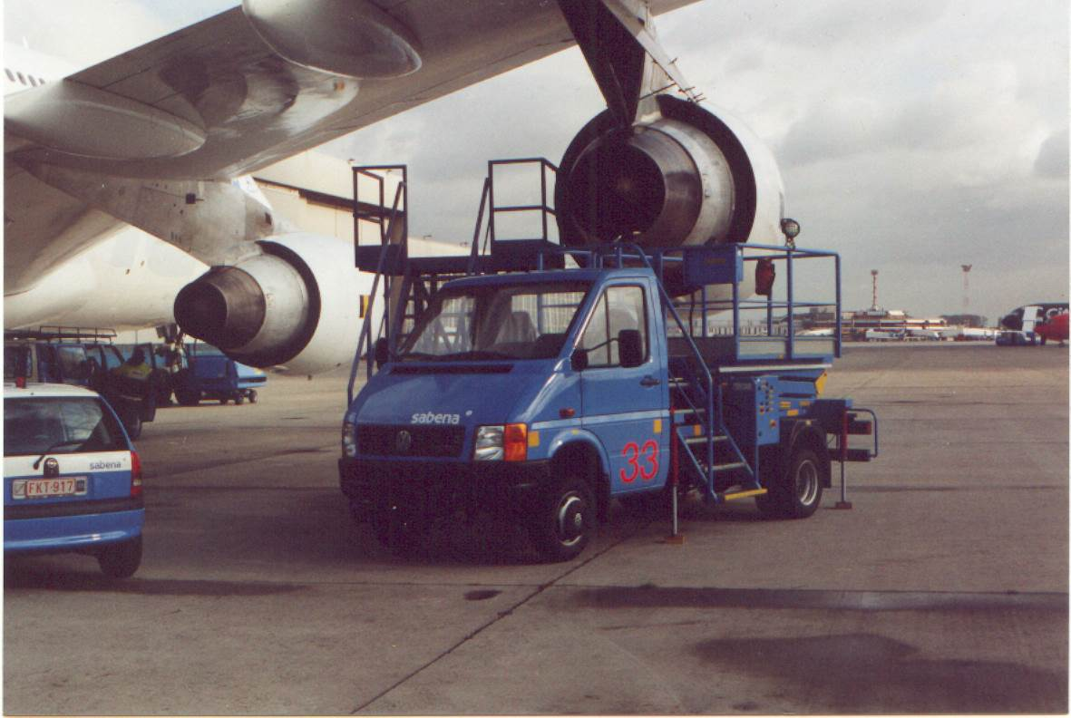

Specifications :

- Basic vehicle: VW Crafter wheelbase 3665, MAN TGE wheelbase 3640, or Mercedes Sprinter wheelbase 3550, Iveco Daily wheelbase 3750, 4.6 tons with PTO ( rear wheel drive) ,or basic vehicle to customers choice
- Minimum platform floor height: 1 metre 50
- Maximum platform floor height: 6 metre 00
- Platform dimensions: 1 metre 50 x 2 metre 02
- Payload: 300 kg
- Vehicle width: 1 metre 95
- Vehicle length: 5 metre 90
- Hydraulic system with Rexroth components
- Electronic engine speed control
- Emergency pump
- 4 stabilizers
- Platform lightning by 2 adjustable lights
- The whole construction is painted in aero paint in order to get skydrol resistance
- Fixed entry stair at the front
- Starting and stopping of the engine via the switch box on the platform
- CE approved

- 2 year warranty on parts

Options
- Hydraulic compressor
- 220 Volts inverter of 2500 Watt
- Hydraulic oil filling system for the aeroplanes with barrel accommodation under the stair.
- Electronic speed limiter with key switch
- Construction to customer specification

